Answer for task 4:
Create database

CREATE DATABASE sales_olap;

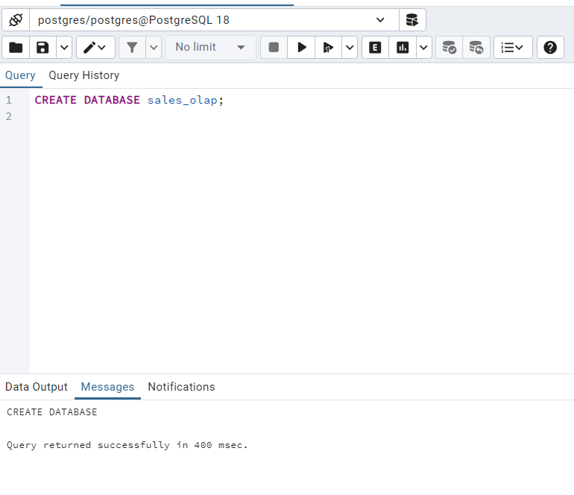
Create sales_sample table
CREATE TABLE sales_sample (
product_id INT,
region VARCHAR(50),
date DATE,
sales_amount NUMERIC
);

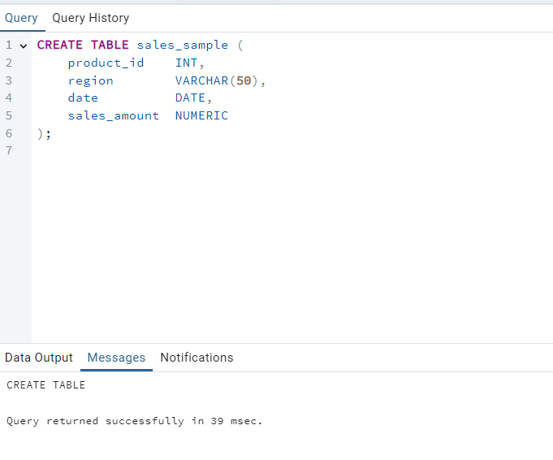

Insert 10 sample records

INSERT INTO sales_sample (product_id, region, date, sales_amount) VALUES
(1, 'East', '2025-01-01', 1000),
(1, 'West', '2025-01-01', 800),
(2, 'East', '2025-01-02', 1200),
(2, 'North', '2025-01-02', 900),
(3, 'South', '2025-01-03', 1500),
(1, 'East', '2025-01-03', 700),
(3, 'West', '2025-01-04', 1100),
(2, 'South', '2025-01-04', 950),
(1, 'North', '2025-01-05', 1300),
(3, 'East', '2025-01-05', 1600);

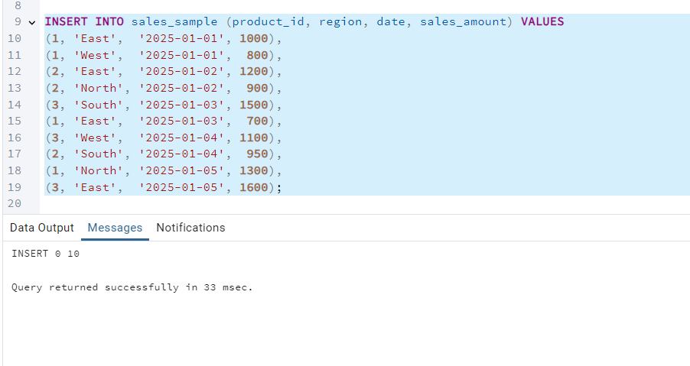

OLAP Queries

Drill Down: region → product level

SELECT
region,
product_id,
SUM(sales_amount) AS total_sales
FROM sales_sample
GROUP BY region, product_id
ORDER BY region, product_id;

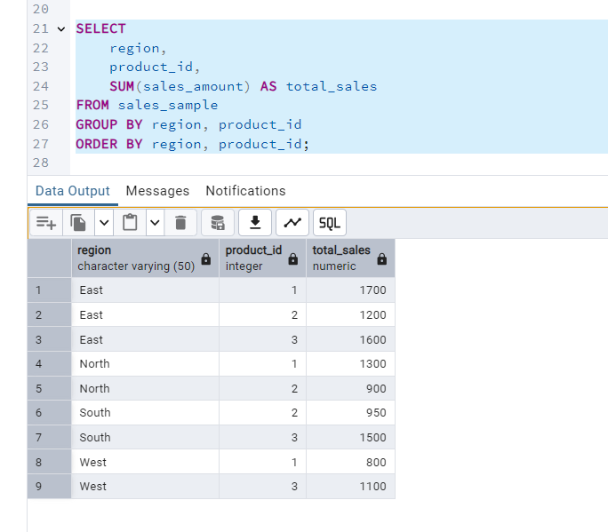

b) Rollup: product → region (total sales by region)
Simple region summary:

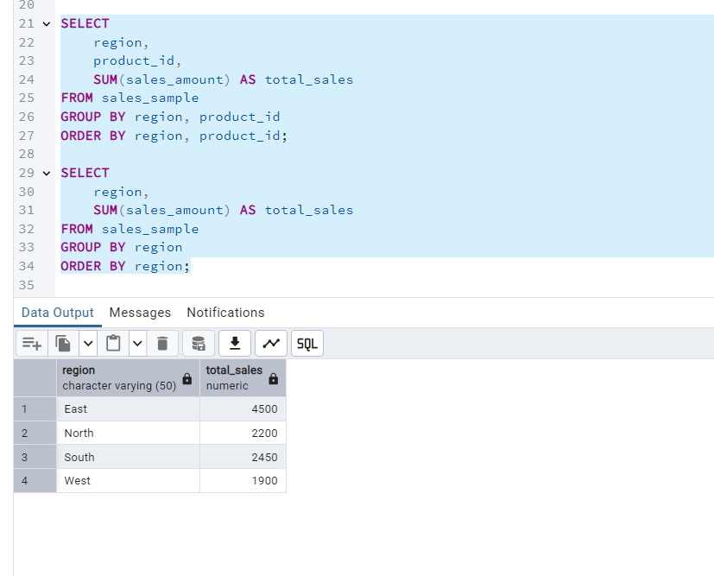

Using ROLLUP (region + grand total):

SELECT
region,
SUM(sales_amount) AS total_sales
FROM sales_sample
GROUP BY ROLLUP (region)
ORDER BY region;

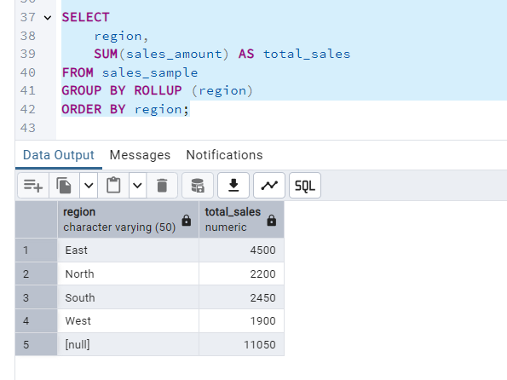

c) Cube: product, region, date

SELECT
product_id,
region,
date,
SUM(sales_amount) AS total_sales
FROM sales_sample
GROUP BY CUBE (product_id, region, date)
ORDER BY product_id, region, date;

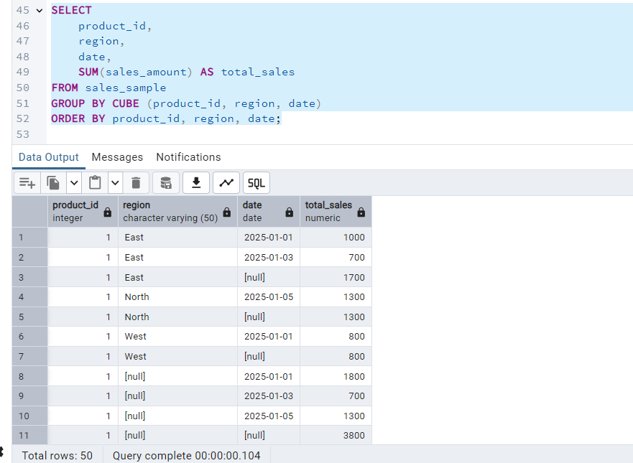

d) Slice: sales for a particular region / date range
Example – region = 'East' and January 1–3:

SELECT
product_id,
region,
date,
sales_amount
FROM sales_sample
WHERE region = 'East'
AND date BETWEEN '2025-01-01' AND '2025-01-03'
ORDER BY date, product_id;
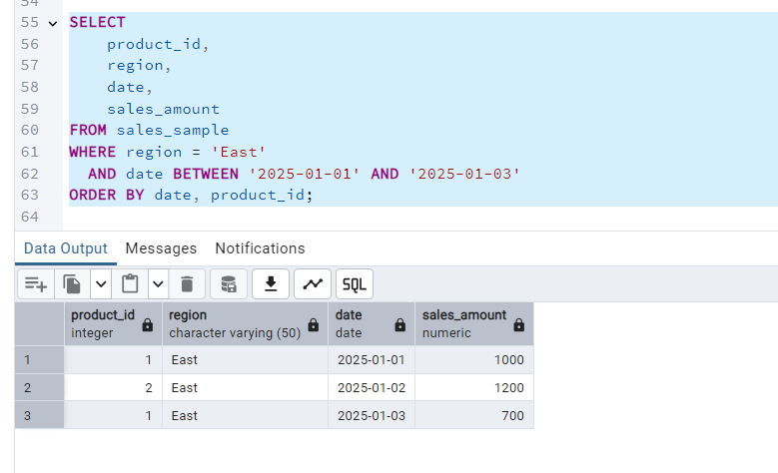

e) Dice: filter by product + region + date
Example – product 1 & 3, regions East/West, specific dates:
SELECT
product_id,
region,
date,
sales_amount
FROM sales_sample
WHERE product_id IN (1, 3)
AND region IN ('East', 'West')
AND date BETWEEN '2025-01-01' AND '2025-01-05'
ORDER BY product_id, region, date;

